|  |  |  |  |  |  |  |
| --- | --- | --- | --- | --- | --- | --- |
| Document Title: **Specification, sound quality evaluation based on time-frequency analyze** | | | | | | |
| Document No: **001** | | | | |  | Rev: **1.0** |
|  | |  | | |  | GN ReSound as  Technology Research  Document |
| Orig. Author | | Chandler Chen | | | Oct 12th , 2017 |
| APPROVALS | | | | | |
| Approver 1 | | [initials] | | | [dd-mm-yyyy] |
| Approver 2 | | [initials] | | | [dd-mm-yyyy] |
| Approver 3 | | [initials] | | | [dd-mm-yyyy] |
| Document Revision History | | | | | | |
| REV | Issue Date | | Change Owner | Change Description | | |
| 1.0 | 2017-10-12 | | Chandler | Initial version | | |
|  |  | |  |  | | |
|  |  | |  |  | | |
|  |  | |  |  | | |
|  |  | |  |  | | |
|  |  | |  |  | | |
|  |  | |  |  | | |
|  |  | |  |  | | |
|  |  | |  |  | | |
|  |  | |  |  | | |
|  |  | |  |  | | |
|  |  | |  |  | | |
|  |  | |  |  | | |
|  |  | |  |  | | |
|  |  | |  |  | | |
|  |  | |  |  | | |
|  |  | |  |  | | |
|  |  | |  |  | | |
|  |  | |  |  | | |
|  |  | |  |  | | |
|  |  | |  |  | | |
|  |  | |  |  | | |
|  |  | |  |  | | |
|  |  | |  |  | | |
|  |  | |  |  | | |
|  |  | |  |  | | |
|  |  | |  |  | | |
|  |  | |  |  | | |
| These drawings and specifications, and the data contained therein, are the exclusive property of GN ReSound issued in strict confidence and shall not, without prior written permission of GN ReSound, be reproduced, copied or used for any purpose whatsoever, except the manufacture of articles for GN ReSound. | | | | | | |



Table of Contents

1. Overview 2

2. Proposals and implementation 2

2.1. Principle 2

2.2. Process 3

2.3. Examples 3

3. Function description 5

Overview

Setup a 2D holography with probe microphone 40SA (GRAS).

This document is a guidance to use this scan system.

Proposals and implementation

## Equipment

NI-PXI4461

Probe microphone 40SA

12AK preamplifier (**GRAS preamplifier is necessary here, like 12AK. The preamplifier of B&K can’t compatible with 40SA**)

Programable robot arm

## Process

How to do this scan work?

Power on all equipment.

Calibrate whole system, mainly the probe microphone 40SA

The calibration of probe microphone is better to be done at yourself station.

Because it needs frequency response calibration, the process:

Calibrate the TBS25 or B&K egg with standard microphone

Replace the microphone with probe microphone, sweep to get the frequency response in a calibrated sound field, like 90dB.

Calibrate the 40SA probe mic with this inverted calibrated frequency response, then we can get the frequency response calibrated probe mic.

Move to the scan platform, Open SoundCheck sequence “2D acoustic Scan_core_txt_out.sqc”

Before running this sequence, **make sure the communication between robot arm and PC is ok**.

Open the MC to check, or send command

Place the HI at the test field, and start running the sequence.

The sequence will output a data text file.

Meanwhile, take a shot of the test field of DUT. This will be used the base of the contour figure.

Run the Matlab Script “read_data_multi_header.m” to make 2D holography figure.

Before instruments test, we need figure out the floor noise in this environment.

No HI is placed, run the SC sequence.

**

From the figure above, we can calculate the noise=

## Examples

This is the pcolor example. No base figure.

*Source vs. output (time field /s)*

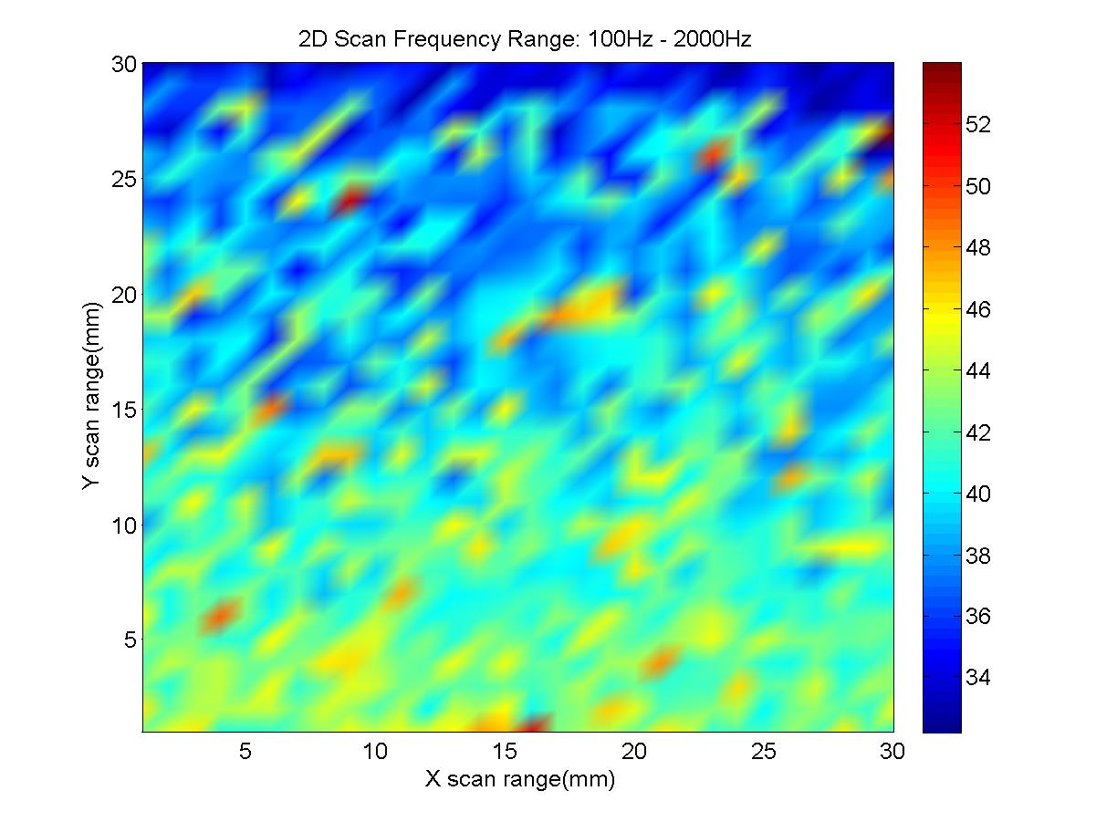

Contour example:

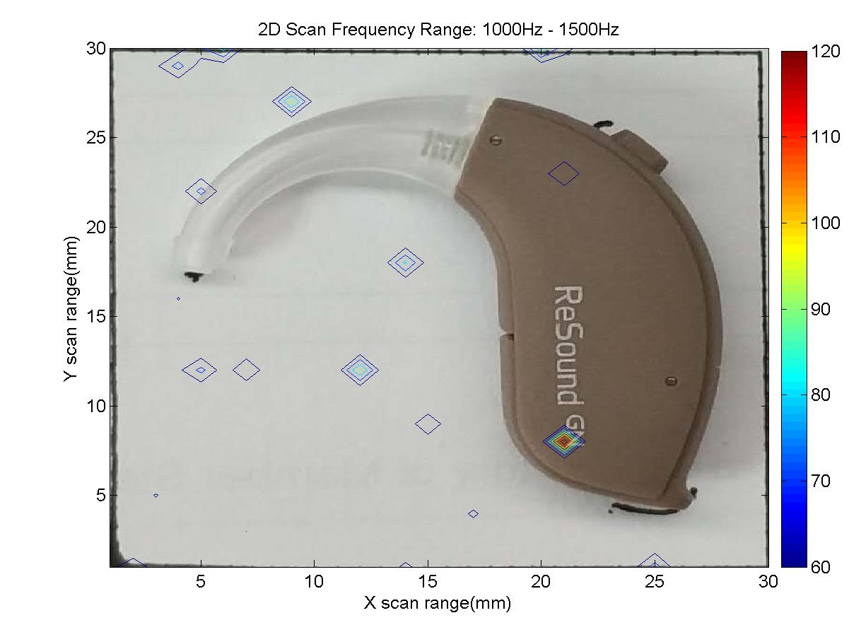

Another example

Make HI feedback, the screaming sound can be heard.

Start the scan, we can get the scan pcolor and contour:

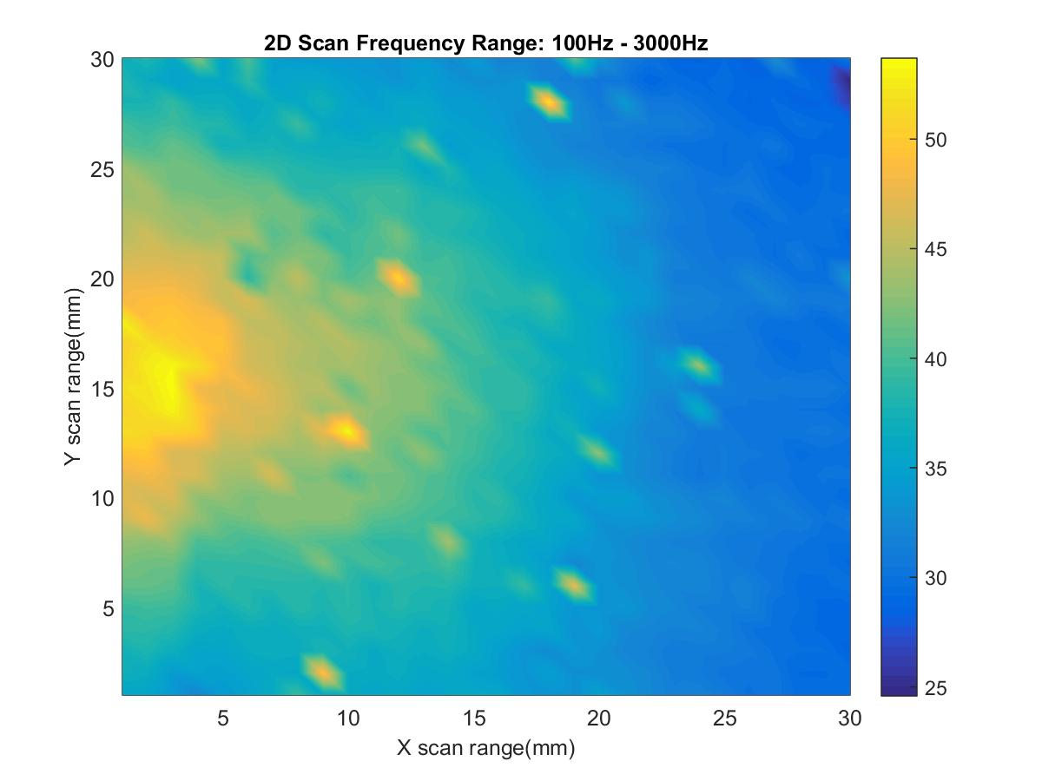

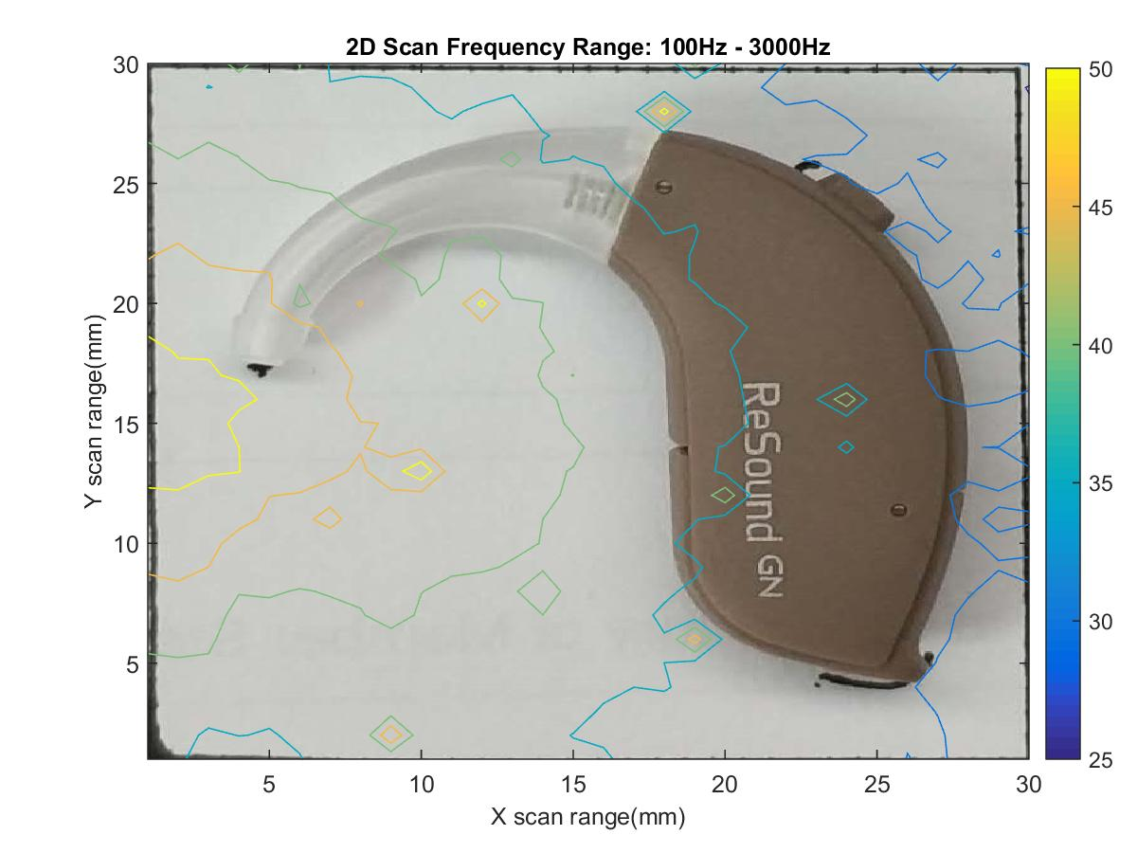

TPIS

It is best to start the scan from the centre of the field arm can cover. To avoid to reach axis end before finishing the test.